
Nektar reports positive 36-week Rezpegaldesleukin data from Phase 2b REZOLVE-AD trial, targeting Q2 2026 Phase 3 start and 2029 BLA submission

Company: Nektar Therapeutics  Drug: rezpegaldesleukin (SC IL-2R agonist T-Reg stimulator) | Date: February 10, 2026  Source(s): press release, webcast, presentation
What happened:
- Nektar Therapeutics announced topline data from the 36-week blinded maintenance period (Week 16-52) of the Phase 2b REZOLVE-AD trial of rezpegaldesleukin (rezpeg; SC IL-2R agonist T-Reg stimulator) in adults with moderate-to-severe atopic dermatitis (AD)
  - Management was joined by KOLs Dr. Silverberg and Rosmarin to review the REZOLVE-AD trial results
- Reported sustained and deepening response with both monthly (Q4W) and quarterly (Q12W) maintenance dosing regimens, particularly at the 24 µg/kg dose selected for Phase 3; safety profile through one year consistent with induction, no new safety signals
  - 71% and 83% of patients maintained EASI-75 responses and 85% and 63% maintained vIGA-AD 0/1 responses on monthly (Q4W) and quarterly (Q12W) dosing, respectively
  - Across key endpoints, responses sustained and deepened through Week 52, including up to a five-fold increase in complete clearance with EASI-100 rates
- Based on the data, Nektar confirmed plans to initiate a 1st monotherapy Phase 3 study (≥12 years) in Q2 2026, in both dosing regimens, with a target date for BLA submission in 2029
- Shared the planned Phase 3 registrational design, including a 24-week Q2W induction followed by re-randomization of responders into Q4W vs Q12W maintenance 28 weeks vs placebo withdrawal
- Separately, Nektar also announced $300 million public offering to fund corporate activities and clinical development, including Phase 3 trials for rezpeg
  - During the webcast, the company mentioned actively exploring collaborations and other financing options to help fund the Phase 3 program

Impact (CI PoV): HIGH
- The 52-week dataset strengthens rezpeg’s positioning, supporting the quarterly maintenance dosing and long-term disease control
- Recall, previously the company guided Phase 3 initiation in 2026 (now Q2 2026); updated guidance to a BLA submission in 2029 places projected approval in Q1 2030
- Rezpeg was granted FDA Fast Track designation for adult and pediatric patients (12 yrs+) with moderate-to-severe AD in February 2025, which may accelerate timelines

Why it matters:
- Rezpeg is being positioned as a long-term disease control option, with data showing sustained responses and additional clearance over one year
  - The ability to maintain responses with quarterly dosing could provide a meaningful convenience advantage if also achieved in Phase 3
- Further, emphasis on EASI-100 may introduce a higher efficacy benchmark in the biologic space, where this endpoint is not routinely achieved; this may influence prescriber expectations and trial enrolment dynamics
- While asthma improvement (ACQ-5, co-morbid asthma 25% study population) was highlighted, maintenance asthma data were not collected; confirmation in Phase 3 will be required before this becomes a validated differentiator
- Recall, rezpegaldesleukin is also being investigated in severe-to-very-severe alopecia areata, currently in Phase 2b REZOLVE-AA
  - CI estimates approval for AA in Q2 2029 for the US (Q3 2029 EU), FDA granted Fast Track designation to severe-to-very-severe AA in July 2025
- Rezpeg is the most mature IL2R agonist in AD clinical development with others in early stage (BMS-986326 IL2/CD25 fusion protein AD Ph1 PCD 11/2025; Egle Therapeutics EGL-003 IL2 mutein HV Ph1 FSD 12/2025)

Tell me more:
Study design
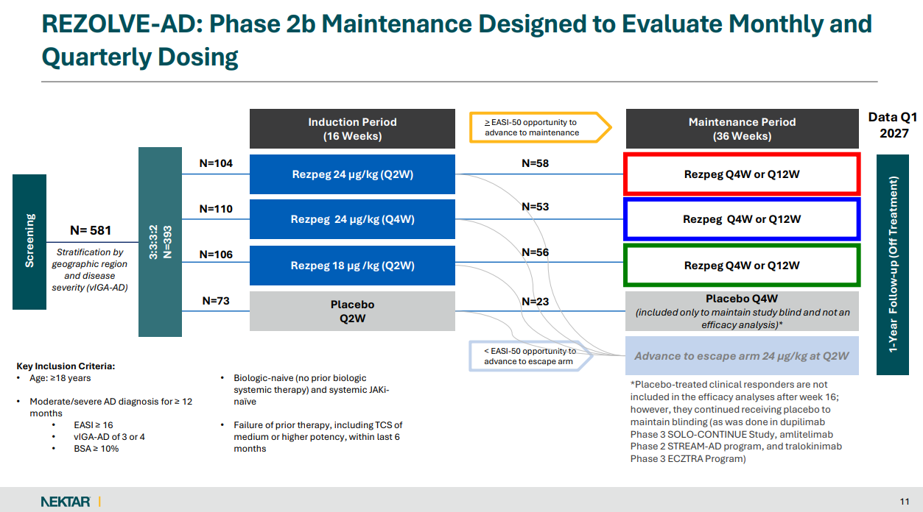

Maintenance endpoints: Proportion of patients maintaining EASI-75, EASI-90, vIGA-AD 0/1, and Itch NRS from Week 16 to Week 52; assessment of new responder conversions and EASI-100 deepening
  - Note, patients only needed ≥EASI-50 to enter maintenance in Phase 2b, Phase 3 will use ≥EASI-75 and/or IGA threshold

Efficacy
- Both Q4W and Q12W arms maintained Week-16 responses across EASI-75, EASI-90, vIGA 0/1, and itch
- Pooled 24 µg/kg durability:
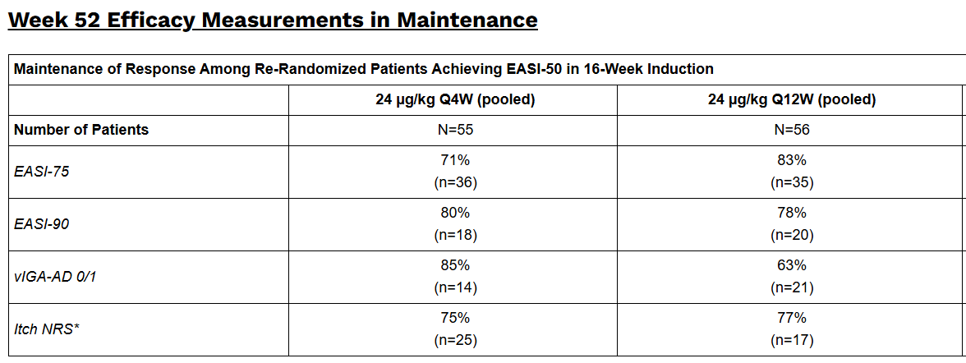
N=xx is the entire maintenance population; (n=xx) is the denominator which equals the number of responders at Week 16; % represents proportion of patients who maintained that response at Week 52
*Only patients with baseline Itch NRS ≥ 4 used as denominator for assessing Itch NRS response

- New responders during maintenance at week 52 (pooled 24 µg/kg):
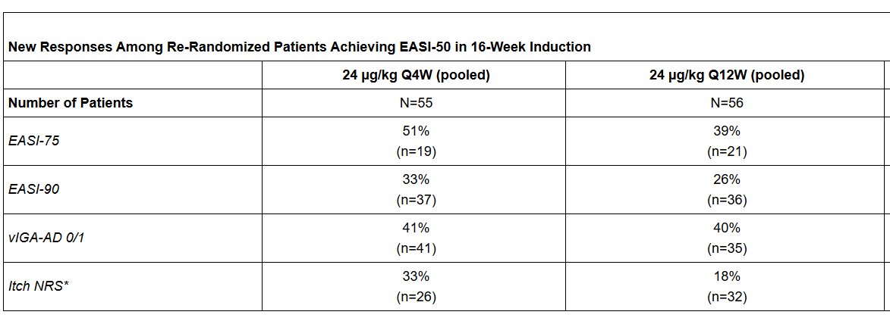
- EASI-100: EASI-100 at week 52 Among ≥ EASI-75 or vIGA-AD 0/1 responders at re-randomization 24 µg/kg increased from 6% to 30% (Q4W) and 14% to 27% (Q12W)
- Cross-trial comparisons were presented vs dupilumab (Phase 3 SOLO-CONTINUE) and amlitelimab (Phase 2 STREAM-AD), with Nektar noting these were not head-to-head studies and emphasizing differentiation, particularly around safety and immune regulation, which may resonate in patients who cycle through existing biologics
- If confirmed in Phase 3 Q12W, dosing can contribute to rezpeg’s positioning message around long-term control and convenient dosing. However, competitive comparisons rely on cross-trial data with different designs and responder criteria so cannot be conclusive

Safety:
- Overall safety through 52 weeks consistent with earlier data
- Discontinuations due to AEs: 3.5%
- Most common TEAE: injection site reactions (ISRs), largely mild/moderate and self-resolving; discontinuations due to ISR: 0.7%;
  - ISR frequency per injection “lower in maintenance vs induction”
  - No imbalance suggesting increased infection risk vs placebo
  - No observed signals for conjunctivitis, facial swelling/erythema, oral ulcers, MI, PE/DVT, or malignancy

Phase 3 Study Design

  - 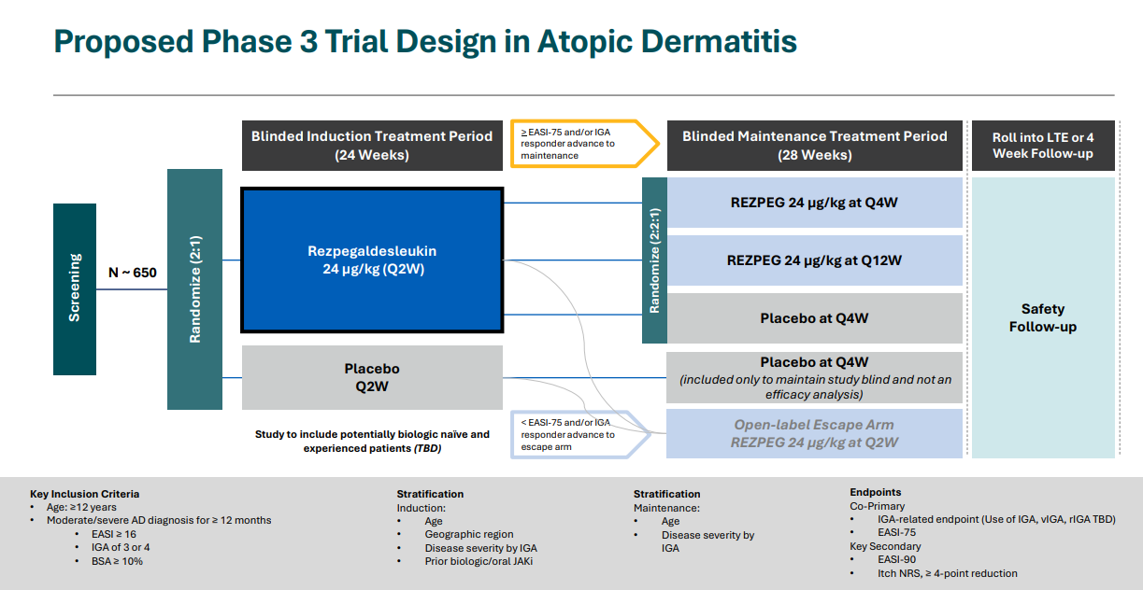
- Treatment duration: 52 weeks
- Asthma outcomes (ACQ-5) planned for prospective evaluation given prior Phase 2 signal in comorbid asthma
- Phase 3 design directly tests Q4W vs Q12W maintenance strategy and will include a withdrawal arm which can clarify how durable responses are without continued dosing

Q&A Highlights Summary
- If Phase 3 data are consistent with Phase 2b results, rezpeg is expected to be used across treatment lines in moderate-to-severe atopic dermatitis. Dr. David Rosmarin (Chair of Dermatology, Indiana University) stated, “Assuming consistency in the Phase 3 program, I’m happy to use rezpeg as first-line treatment (…) I expect to use it both as first-line as well as later-line therapy.” Similarly, Dr. Jonathan Silverberg (Professor of Dermatology, George Washington University) commented, “This really can be a first-line contender and certainly has a real positioning for the preferred second line as well.”
- When asked about potential penetration of rezpeg among biologic eligible AD patients, KOLs avoided precise forecasts due to access and payer variability but expressed confidence in meaningful uptake. Dr Silverberg noted, “I could throw out a random number of 25% or more, but I honestly don’t know yet, there are lot of variables”,
- KOLs urged caution around the term “remission”, but acknowledge strong durability and persistence of effect, particularly with quarterly dosing: “We have to be very precise and careful when we use terms like remitted effect (...) What we can be comfortable with, especially with the Q12W maintenance data, is a nice persistence effect”, affirmed Dr. Silverberg
- Both KOLs favored Q12W dosing for stable patients and highlighted its real-world appeal. Dr. Rosmarin stated, “Having a medicine that you only dose four times a year is very attractive for people (...) if the patient is doing fantastic clinically, but is getting ISRs, that might be the perfect patient to go to a Q12W maintenance dose (...) even at the 12-week mark, any worsening of itch was extremely low”, followed by Dr. Silverberg reinforcing this view, noting, “The Q12W data looks so good, it really offers the opportunity to balance”
- Injection Sites Reaction (ISRs) were repeatedly framed as manageable and less problematic than other biologic-associated adverse events; however, conjunctivitis and facial erythema were described as difficult-to-treat in real-world practice: , “To me, ISRs are more of a tolerability issue than a safety issue (...) I’ve never had a patient ask me, ‘what's the ISR rate? (...) Conjunctivitis and facial erythema are not easy to navigate through in practice”, described by Dr. Silverberg, and followed by Dr. Rosmarin mentioning: “what patients truly care about is that they don’t want to be hurt”
- Complete clearance (EASI-100), was described as rare for biologics and potentially paradigm-shifting: “There’s a reason you haven’t heard about EASI-100 with biologics, we generally don’t get there”, affirmed Dr. Silverberg
- When durability was questioned with such infrequent dosing, management attributed durability to regulatory T-cell biology rather than drug exposure alone “This is truly the promise of an immunomodulatory drug, the pharmacodynamic effect substantially outlasts pharmacokinetics; some studies suggest T-regulators can persist in tissue for years once inflammation is controlled (...) This helps explain why once-monthly or once-every-12-week dosing still works ”

Relevant slides:
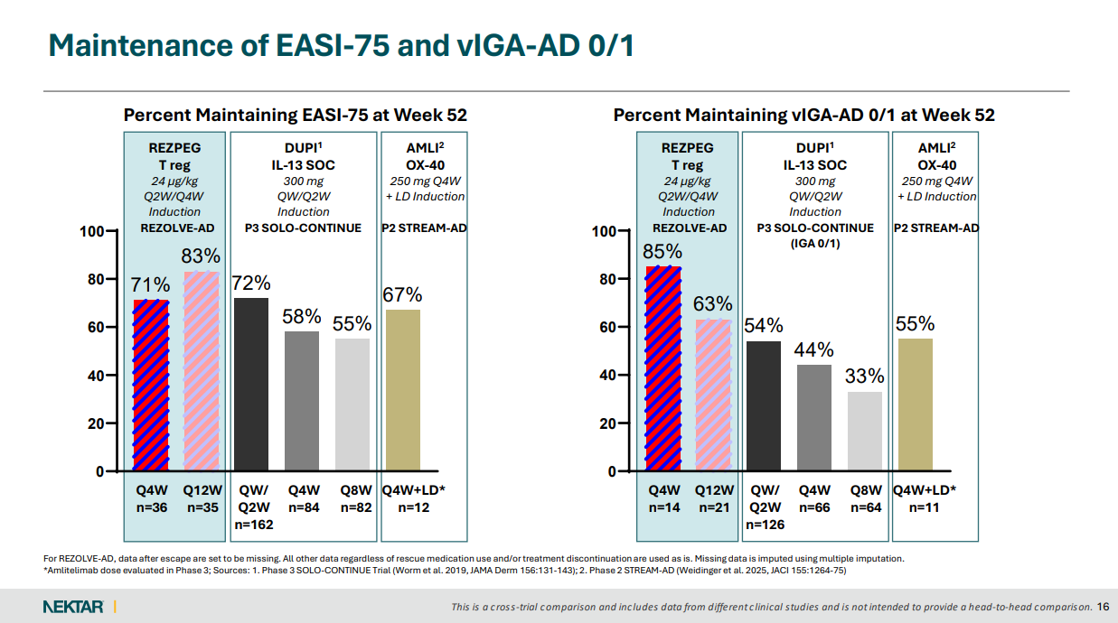
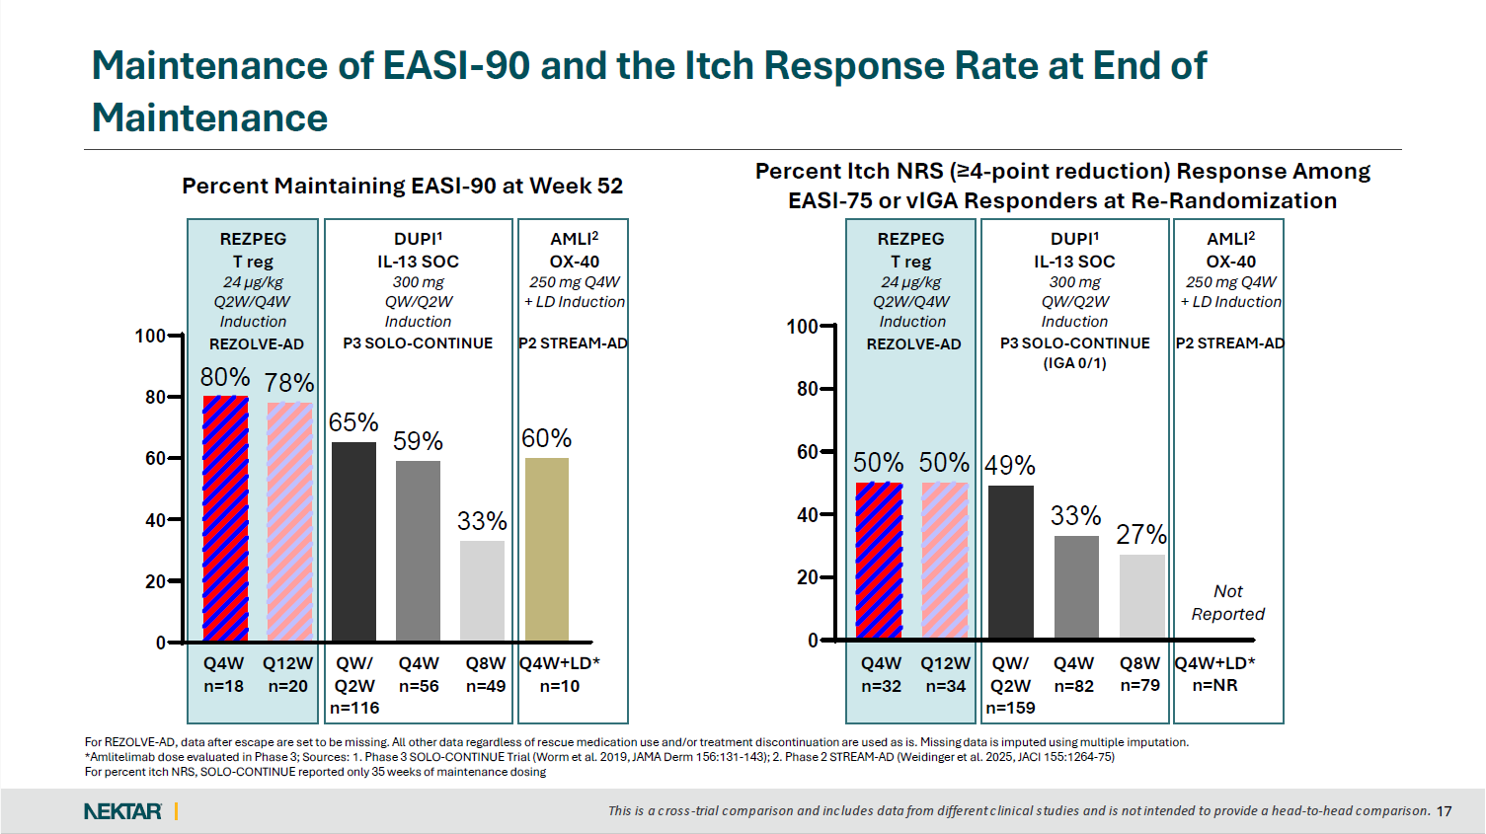

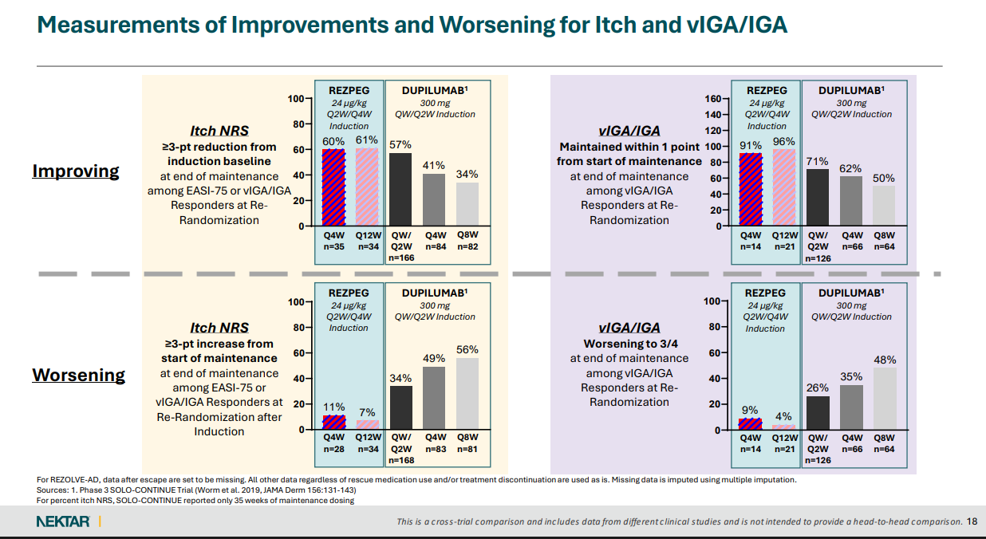

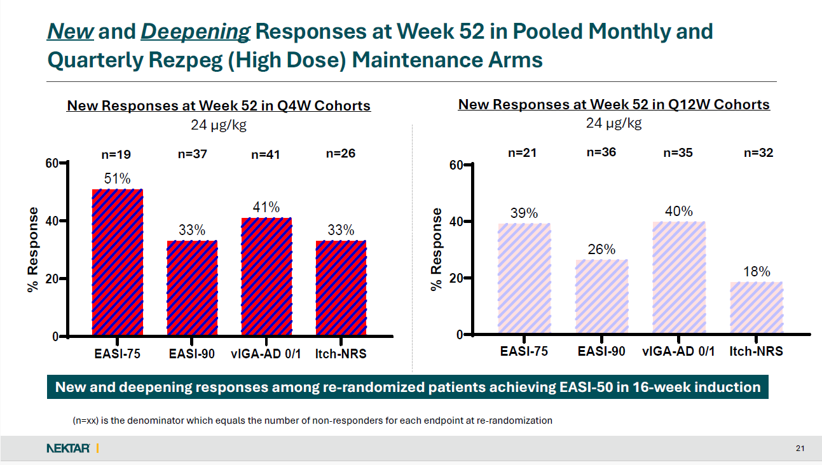

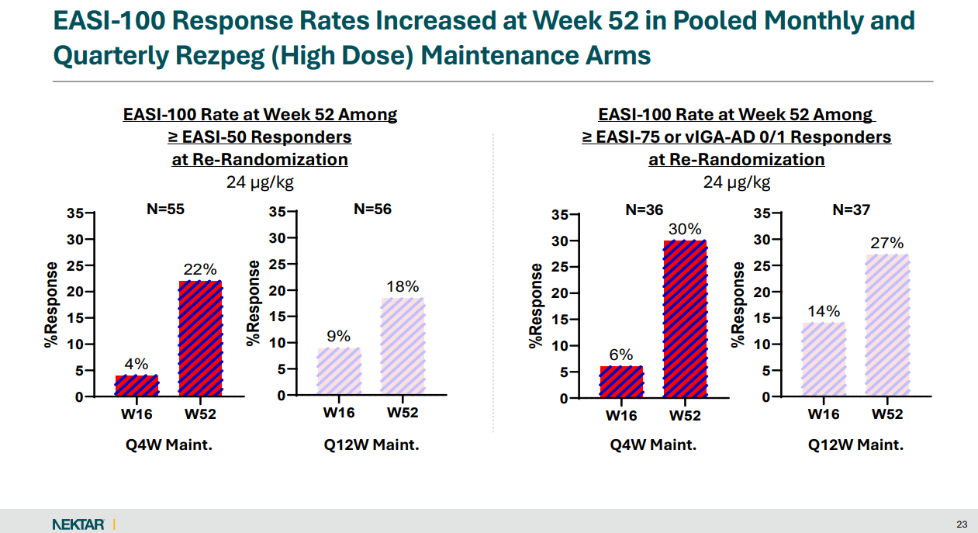

For questions, please reach out to:
 | Dermatology | Rheumatology | Gastroenterology
APEX (US/PCS) | Chanda Bhat | Bethany Christmann | Luke Versten
IMABI (International/ Affiliates) | Priti Anand | Irene Knorn | Priti Anand

Invite your colleagues to inVision | Manage Email Preferences | Unsubscribe

This document/email contains competitive intelligence collected via an approved competitive intelligence supplier working on behalf of AbbVie. We collect competitive intelligence consistent with industry standards and AbbVie policy. Not for field distribution. Please reach out to APEX/IMABI, Legal, or OEC teams with any questions.

